

**CLASSIFICATION OF DIABETIC RETINOPATHY USING CONCEPTS OF MACHINE LEARNING**

**A report submitted in partial fulfillment of the requirements Of**

## Mini-Project (IS65)

**In**

##### Sixth Semester By

**1MS20IS104 Sanidhya Jain 1MS20IS124 Syed Reehan Siddiq 1MS20IS137 Yogesh Sanghi 1MS20IS138 Zeeshan Ahmad**

**Under the guidance of**

**Dr. S R Mani Sekhar** Assistant Professor Dept. of ISE, RIT

# RAMAIAH

**Institute of Technology**

##### DEPARTMENT OF INFORMATION SCIENCE & ENGINEERING

**RAMAIAH INSTITUTE OF TECHNOLOGY**

**(AUTONOMOUS INSTITUTE AFFILIATED TO VTU)**

**M. S. RAMAIAH NAGAR, M. S. R. I. T. POST, BANGALORE – 560054**

##### 2022-2023

XXX-X-XXXX-XXXX-X/XX/$XX.00 ©20XX IEEE

**RAMAIAH INSTITUTE OF TECHNOLOGY**



**(Autonomous Institute Affiliated to VTU)**

**M. S. Ramaiah Nagar, M. S. R. I. T. Post, Bangalore – 560054**

**DEPARTMENT OF INFORMATION SCIENCE AND ENGINEERING**

# RAMAIAH

**Institute of Technology**

### CERTIFICATE

This is to certify that the project work entitled **“CLASSIFICATION OF DIABETIC RETINOPATHY USING CONCEPTS OF MACHINE LEARNING”** is a bonafide work carried out by **Sanidhya Jain** bearing **USN: 1MS20IS104, Syed Reehan Siddiq** bearing **USN: 1MS20IS124, Yogesh Sanghi** bearing **USN: 1MS20IS137, Zeeshan Ahmad** bearing **USN: 1MS20IS138** in partial fulfillment of requirements of Mini-Project (ISL65) of Sixth Semester B.E. It is certified that all corrections/suggestions indicated for internal assessment have been incorporated in the report. The project has been approved as it satisfies the academic requirements in respect of project work prescribed by the above said course.

###### _________________________ _________________________

Signature of the Guide Signature of the HOD

**Dr. S R Mani Sekhar Dr. Sanjay H A**

Assistant Professor Professor and Head,

Dept. of ISE, RIT, Dept. of ISE, RIT

Bangalore-54 Bangalore-54

Other Examiners

###### Name of the Examiners: Signature

1.

2.

**Abstract**

Diabetic Retinopathy is an ocular disorder that can result in loss of vision and even blindness among individuals with diabetes. The condition specifically affects the blood vessels located in the retina. Therefore, it is really important to cure this disease and undergo specific treatment. It is crucial to diagnose diabetic retinopathy early and receive prompt medical treatment in order to prevent the serious consequences associated with the condition. This can help to minimize the harmful effects of diabetic retinopathy on vision and overall eye health.

Manual detection of Diabetic Retinopathy by ophthalmologists is very time consuming, hence there is a need to improvise on the current method of treatment. This paper focuses on providing a way to detect the disease at a very early stage, so that complications do not arise in the later stages. The dataset used was taken from Asia Pacific Tele-Ophthalmologist Society (APTOS) 2019 conference. The model was implemented using KNN. In this method, an accuracy of 66% was achieved along with a confirmation that the dataset is reliable. In the second method, the Attention Model was used. With this model, an accuracy of 45% was achieved. Lastly, to improve the accuracy, a different method named Inception Version 3 (IV3) was used. In this method, the accuracy greatly improved and came out to be 79%.

This paper focuses on the Inception V3 (IV3) method to classify the severity of Diabetic Retinopathy. As spoken earlier, the accuracy improved when the method was changed to IV3. The dataset was split into 70% training and 30% testing using cross validation. Overall, this paper aims to present a model where time consumption is relatively less and computation costs are considerably reduced.

*Classification of Diabetic Retinopathy using Concepts of Machine Learning*

S R Mani Sekhar

*Dept. of ISE*

*M S Ramaiah Institute of Technology* Bengaluru, India [manisekharsr@msrit.edu](mailto:manisekharsr@msrit.edu)

Yogesh Sanghi

*Dept. of ISE*

*M S Ramaiah Institute of Technology* Bengaluru, India [yogeshsanghi1521@gmail.com](mailto:yogeshsanghi1521@gmail.com)

Sanidhya Jain

*Dept. of ISE*

*M S Ramaiah Institute of Technology*

Bengaluru, India

[sanidhyajain45@gmail.com](mailto:sanidhyajain45@gmail.com)

Zeeshan Ahmad

*Dept. of ISE*

*M S Ramaiah Institute of Technology*

Bengaluru, India

[ahmad.zeeshan.za81@gmail.com](mailto:ahmad.zeeshan.za81@gmail.com)

Syed Reehan Siddiq

*Dept. of ISE*

*M S Ramaiah Institute of Technology*

Bengaluru, India

[syedreehan998@gmail.com](mailto:syedreehan998@gmail.com)

###### *Abstract*— Diabetic Retinopathy is an ocular disorder that can result in loss of vision and even blindness among individuals with diabetes. The condition specifically affects the blood vessels located in the retina. Therefore, it is really important to cure this disease and undergo specific treatment. It is crucial to diagnose diabetic retinopathy early and receive prompt medical treatment in order to prevent the serious consequences associated with the condition. This can help to minimize the harmful effects of diabetic retinopathy on vision and overall eye health.

**Manual detection of Diabetic Retinopathy by ophthalmologists is very time consuming, hence there is a need to improvise on the current method of treatment. This paper focuses on providing a way to detect the disease at a very early stage, so that complications do not arise in the later stages. The dataset used was taken from Asia Pacific Tele-Ophthalmologist Society (APTOS) 2019 conference.**

###### The model was implemented using KNN. In this method, an accuracy of 66% was achieved along with a confirmation that the dataset is reliable. In the second method, the Attention Model was used. With this model, an accuracy of 45% was achieved. Lastly, to improve the accuracy, a different method named Inception Version 3 (IV3) was used. In this method, the accuracy greatly improved and came out to be 79%.

**This paper focuses on the Inception V3 (IV3) method to classify the severity of Diabetic Retinopathy. As spoken earlier, the accuracy improved when the method was changed to IV3. The dataset was split into 70% training and 30% testing using cross validation. Overall, this paper aims to present a model where time consumption is relatively less and computation costs are considerably reduced.**

***Keywords—Diabetic Retinopathy, APTOS, IV3, KNN, Machine Learning, Blindness Detection, Ophthalmologist.***

1. ***INTRODUCTION***

Diabetic Retinopathy is a condition in which the eye is affected due to high blood sugar levels, It can lead to harmful consequences like losing vision. Around the world, the most common reason why people turn blind at a later stage in their life is Diabetic Retinopathy. Diabetic Retinopathy is a complication of diabetes that can cause damage to the retina, which is the part of the eye that detects light and sends signals to the brain. This damage can cause abnormal blood vessels to grow out of the retina and block fluid from draining out of the eye. This can lead to a type of glaucoma that can cause vision loss and blindness. Additionally, Diabetic Retinopathy can cause scars to form in the back of the eye. Some of the most common symptoms of Diabetic Retinopathy include gradually worsening vision, sudden vision loss, floaters, blurred or patchy vision, eye pain or redness, and difficulty seeing in the dark.

According to the International Diabetes Federation (IDF), it is estimated that approximately one-third of people with diabetes have diabetic retinopathy. As of 2021, there were approximately 463 million adults aged 20-79 years with diabetes worldwide, according to the IDF. This means that approximately 154 million people worldwide may be affected by diabetic retinopathy.

Although there are manual treatments available where ophthalmologists treat this condition, the main drawbacks in this method are that they are very time consuming. The time lost here can actually lessen the chances of the patient’s chances of completely getting rid of this disease. Hence, it becomes really essential that a computer-aided system is in place for the detection of this disease. With the help of Machine Learning, this paper looks at this challenge and gives out a quicker method to detect the condition of Diabetic Retinopathy among adults.

There are mainly 5 stages in Diabetic Retinopathy -

1. No apparent retinopathy
2. mild non-proliferative DR (NPDR)
3. moderate NPDR
4. severe NPDR
5. Proliferative DR (PDR)

In this paper, the dataset which is used is taken from Asia Pacific Tele-Ophthalmologist Society (APTOS) 2019 conference.

As a trial measure, in the initial stage, the KNN algorithm was used where an accuracy of 66% was achieved. But this was binary classification where the model predicted whether a patient had Diabetic Retinopathy or not. The larger aim was to detect and classify which stage of Diabetic Retinopathy was it. As explained above, the severity of the disease was divided into 5 classes.

The next step was using the Attention Model. This involved multi classification but the major drawback here was that it was not yielding a good accuracy score. The accuracy achieved here was 45%. This score was not at all acceptable.

The method which this paper emphasizes on is the IV3 method. Google researchers unveiled Inception V3, a deep convolutional neural network architecture, in 2015. It is intended for picture classification and object recognition applications and is a member of the Inception family of neural networks.

Convolutional and pooling procedures are spread out over several layers in Inception V3, which are followed by fully linked layers for classification. The use of "Inception modules," which enable the network to productively learn features at various dimensions and resolutions, is one of the fundamental

advances of Inception V3. The application of "batch normalization," which facilitates training and enhances the network's accuracy, is another breakthrough.

Inception V3 demonstrated cutting-edge performance on a number of benchmark tests after being trained on expansive picture classification datasets like ImageNet.

Inception V3 has been trained on large-scale image classification datasets such as ImageNet and achieved state-of-the-art performance on several benchmark tests. It has been extensively used in applications such as object detection, image recognition, and visual question answering.

Around 1426 samples were collected, and put to training. When this method was applied to this particular dataset, an accuracy of 79% was achieved. This accuracy was better than what was achieved by using the KNN model and the Attention Model.

#### LITERATURE SURVEY

In [1], the authors have illustrated using the Support Vector Machine method and it is applied to a certain Region of Interest. The dataset used was the APTOS 2019 Blindness Detection Dataset. Using SVM, an accuracy of 85.7% was achieved. But this was just binary classification. One of the major limitations of this paper was that the image quality was a bit compromised and some DR labels might have been erroneous.

In [2], the authors of the paper have discussed the Steerable Kernelized Partial Derivative and Platt Scale Classifier (SKPD-PSC) method. In this paper, the DIARETD80 dataset was used. The accuracy improved a lot. The future work in this paper involves benchmarking the performance of deep learning techniques in a small dataset.

In [3], the paper presents another use of the Support Vector Machine method. In this, the accuracy achieved was 90%, but it was only binary classification. The dataset used was the MESSIDOR dataset. The future work involves improving the performance of the Machine Learning techniques.

In [4], the authors of the paper have demonstrated the use of the Convolutional Neural Network. The dataset was picked up from Kaggle. An accuracy of 91% was achieved, but this was also a binary classification.

In [5], the authors have talked about the Support Vector Machine method. The MESSIDOR dataset was used and the accuracy achieved was 90%. This too was a binary classification. The future work in this paper involves improving the Machine Learning techniques.

In [6], the authors tried to develop the model using hardware, where a deep learning method was involved. Accuracy achieved was 88.5%. The Eyepacs dataset from APTOS was used. Although a binary classification, this was the first such publication which had worked on a hardware model also.

In [7], the authors have discussed the model where they used a method called Pattern Classifier Algorithm. The MESSIDOR dataset was used and an accuracy of 92% was used. This was also a binary classification.

In [8], the paper was published by developing the models Probabilistic Neural Network and Bayes Classifier. The DIARETD80 dataset was used and the accuracy for PNN was 89.6% and for Bayes Classifier was 92.4%. The future work in this paper focuses on improving the efficiency of the correct classification by extracting better features and by increasing the number of data in each class and by combining them with other pattern classification models.

#### PROPOSED SOLUTION

In the proposed solution, the methodology is described which is a high-level overview of the steps involved in developing and training a machine learning model for image classification. Let's dive deeper into each step to understand it better.

1. Collecting the Dataset:

This is the first and crucial step in developing a machine learning model. The dataset should be relevant and sufficient in size to train a model that can generalize well on new unseen data. Choosing the wrong dataset can lead to inaccurate results. The dataset must be properly annotated, labeled, and organized.

1. Importing Libraries:

Python is the most commonly used language for developing machine learning models. There are various libraries available in Python that make it easier to develop machine learning models. For example, TensorFlow, PyTorch, and Keras are popular libraries for developing deep learning models.

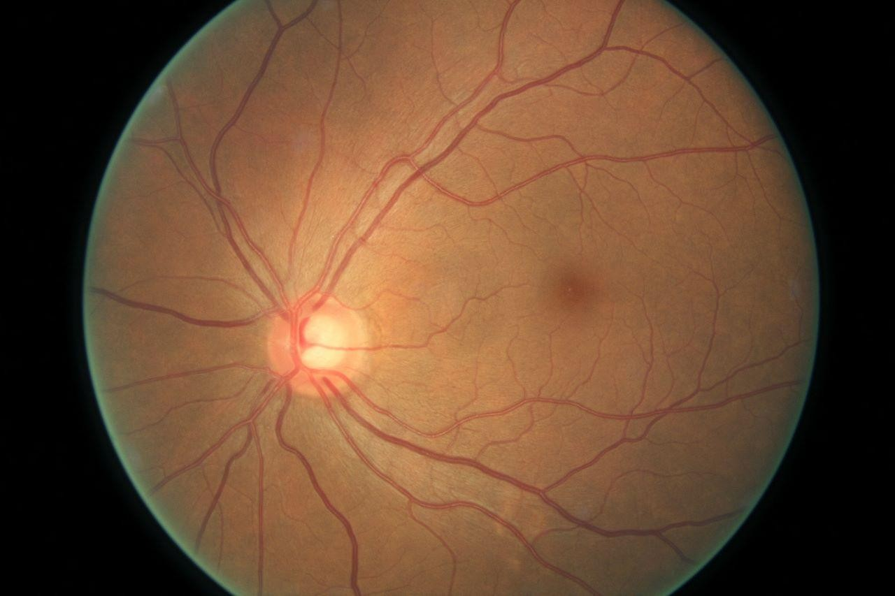

Fig. 1. Normal image of eye

1. Mapping the Dataset:

The dataset is usually provided in the form of images. Before training the model, the images must be mapped to the corresponding CSV file, which contains the labels for each image. This mapping is done to facilitate the processing of images during the training phase.

1. Data Pre-processing and Augmentation:

Data pre-processing involves transforming the raw data into a suitable format for training the model. This includes resizing the images, normalizing the pixel values, and converting the

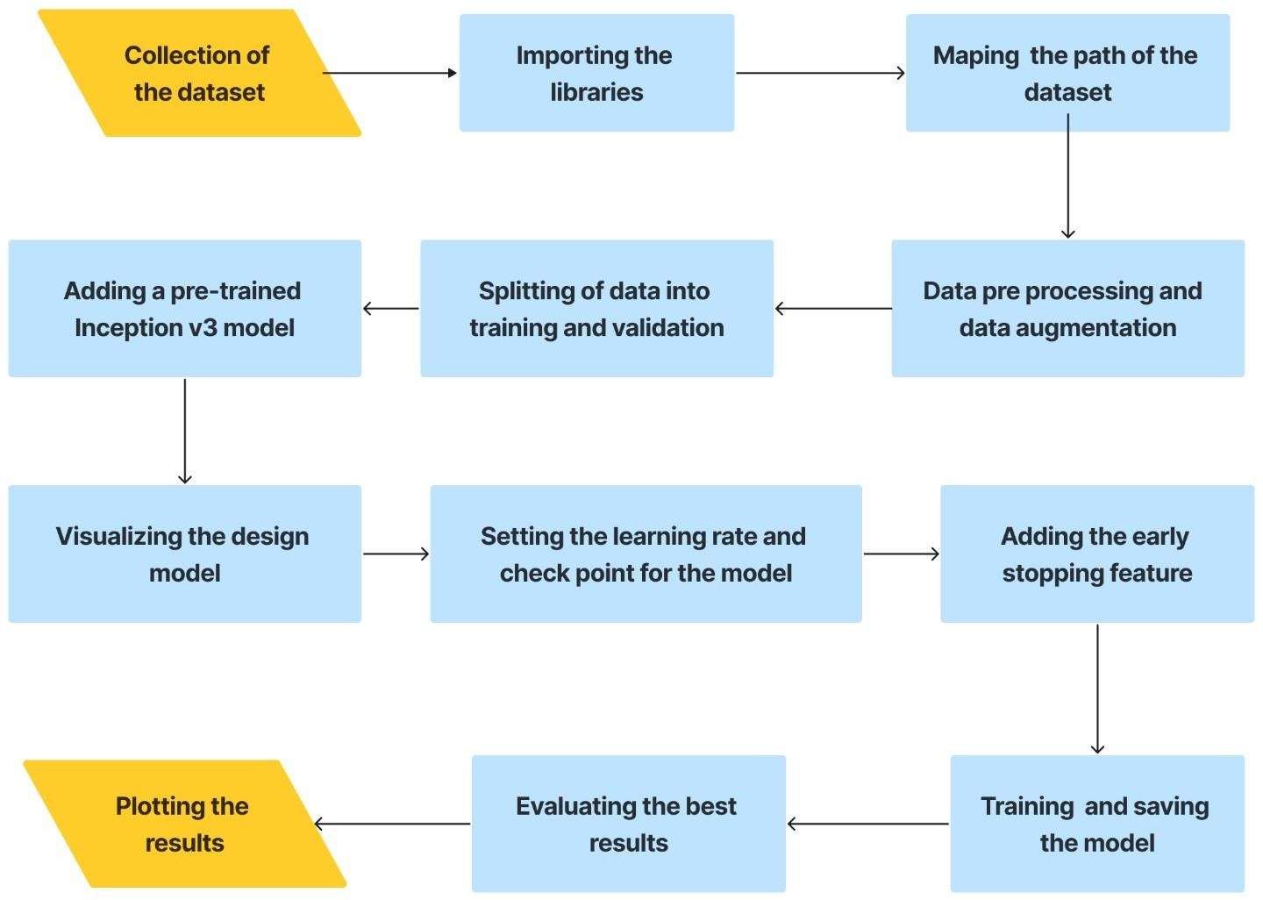

Fig. 2, The entire methodology in a flowchart

images to a tensor format. Data augmentation is done to increase the size of the dataset by applying transformations such as rotations, flips, and zooming. This helps in reducing overfitting and improving the model's generalization capabilities.

1. Splitting the Dataset:

The dataset is split into a training set and a testing set. The training set is used to train the model, and the testing set is used to evaluate the model's performance. The standard split is 70% for training and 30% for testing.

1. Adding and Visualizing Pre-trained Model:

The InceptionV3 (IV3) model is a pre-trained model that has been trained on a large dataset. It is a powerful model that can be used for image classification tasks. The pre-trained model is added to the project and visualized to understand its architecture.

1. Setting Learning Rate and Checkpoint:

Learning rate determines the step size at which the model updates the weights during training. It is set to an optimal value to ensure that the model converges faster and avoids overshooting the global minimum. A checkpoint is set to save the best model during training.

1. Adding Early Stopping Feature:

The early stopping feature is added to prevent the model from overfitting. It stops the training process when the model's performance on the validation set starts to degrade.

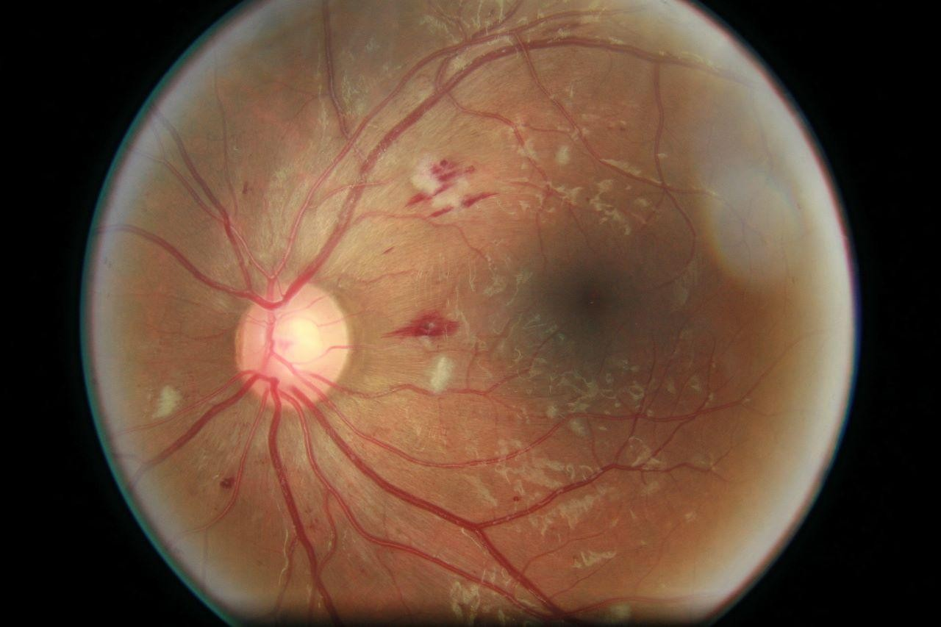

Fig. 3. Affected eye

1. Training and Saving the Model:

The model is trained using the training set and the IV3 pre-trained model. The model's performance is monitored during training using the validation set. The best model is saved using the checkpoint.

1. Evaluating the Results:

The model's performance is evaluated on the testing set to check its generalization capabilities. The accuracy of the model is calculated to assess its performance.

1. Plotting the Results:

The results are plotted on a graph to visualize the performance of the model during training and testing. The accuracy of the model is calculated and displayed on the graph.

In summary, developing a machine learning model involves several steps, from collecting the dataset to evaluating the results. Each step is crucial and requires careful consideration to ensure accurate and reliable results.

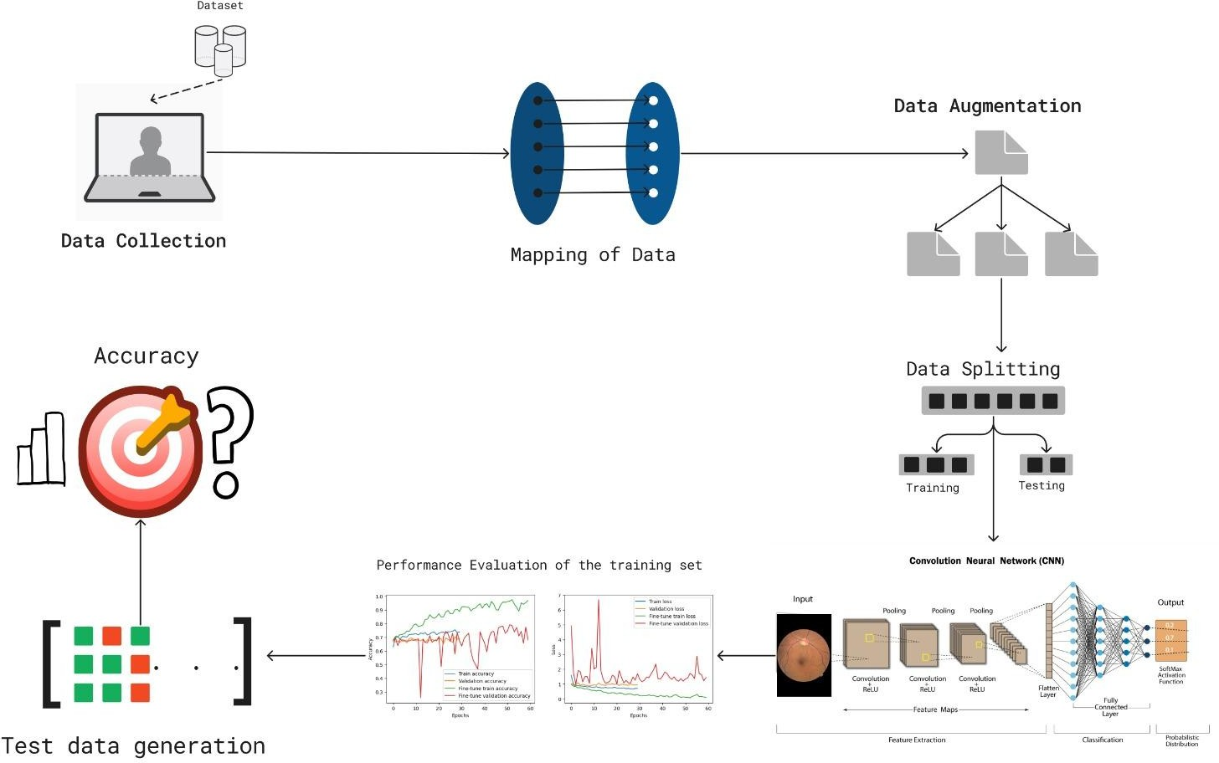

Fig. 4. The procedure of IV3 step by step

The above figure describes the entire methodology in a very detailed manner, starting from data collection and mapping right until determining the accuracy, passing through steps like Data Augmentation, Data Splitting. The figure also shows the entire concept of Convolutional Neural Network (CNN) in detail in the bottom right corner. For more clarity, the zoomed in view of that part of the image will be given below.

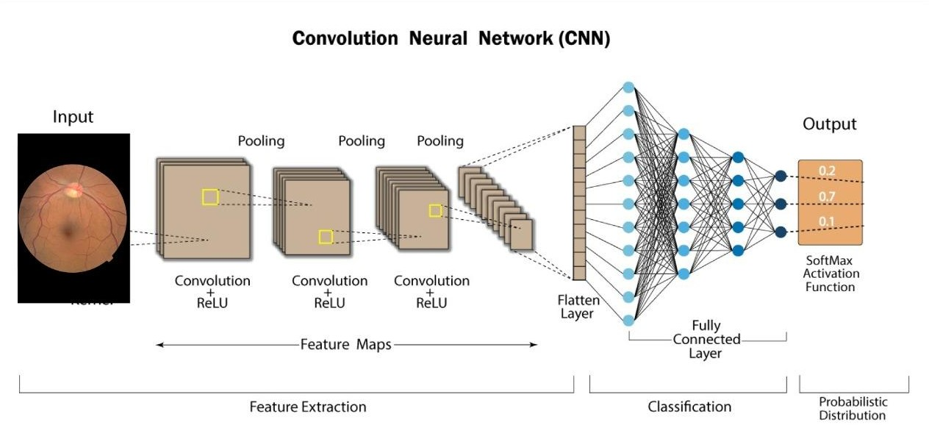

Fig. 5. CNN model with respect to the proposed work

#### RESULTS AND DISCUSSION

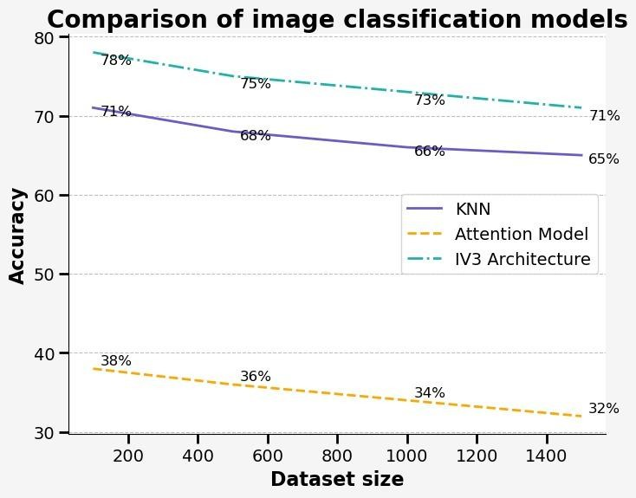

Fig. 6. Comparison of image classification of models

Upon applying all the above three mentioned methods of KNN, Attention Model and lastly, Inception Version 3 (IV3), the result was that the highest accuracy was achieved in the IV3 model. Numerically speaking, the accuracy in KNN was 66%. In the Attention Model, the accuracy achieved was 32% for the largest dataset. However, the method which is being specifically proposed in this paper is the IV3, and that model gave an accuracy of 79% for a smaller dataset of 160 images, and for a large dataset of 1426 images, the accuracy was 71% which is quite an improvement from the other methods.

Above is a graph shown which shows the comparison of all the three methods on different sizes of the dataset. The number of images in the dataset varies from 150 to 1500.

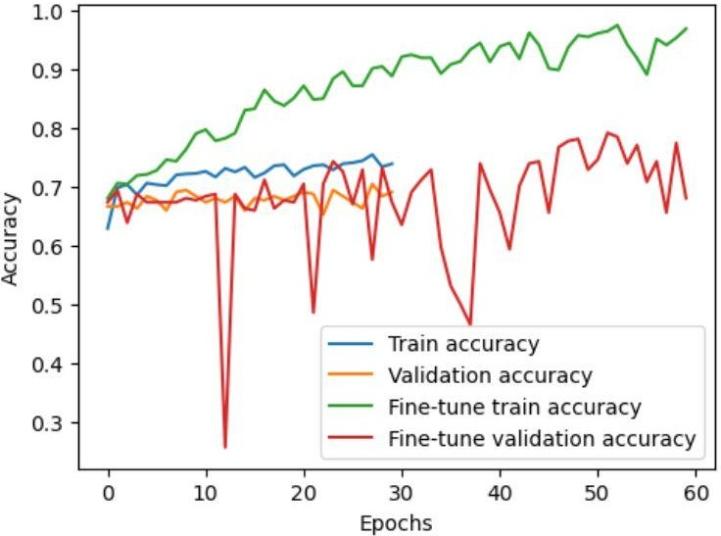

Fig. 7. Accuracy v/s Epochs graph

As said earlier, the dataset was taken from the Asia Pacific Tele-Ophthalmologist Society (APTOS) 2019 conference.

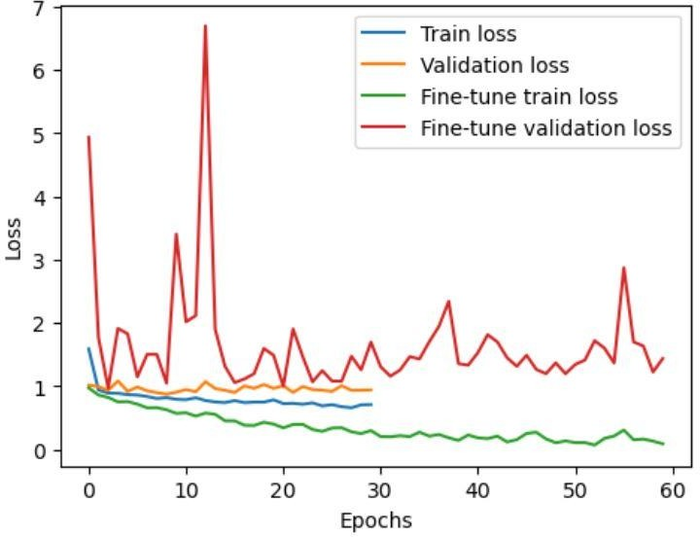

Fig. 7. Loss v/s Epochs graph

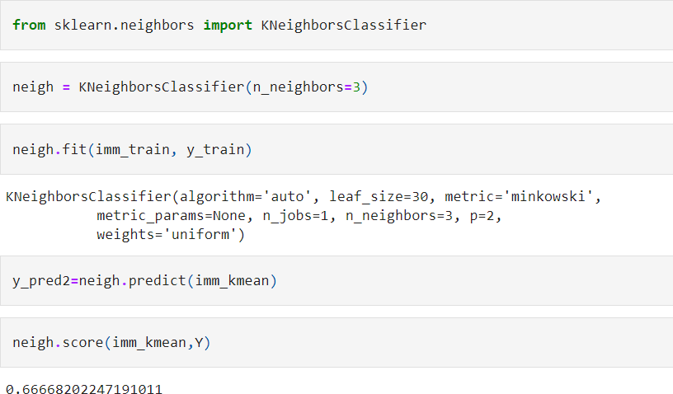

Fig. 8. Accuracy using KNN

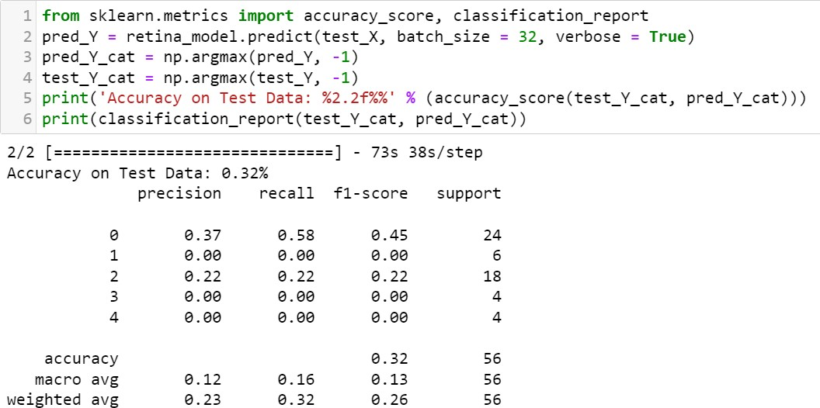

Fig. 9. Accuracy using the Attention Model

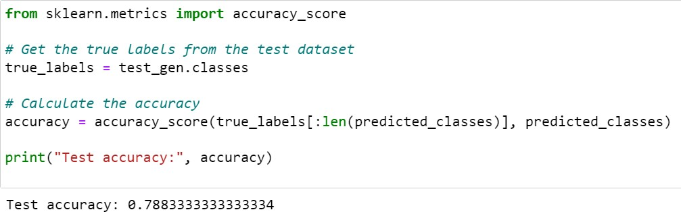

Fig. 10. Accuracy using IV3

#### CONCLUSION AND FUTURE SCOPE

Diabetes among people is rising around the world at an alarming rate. With the menace of diabetes, comes Diabetic Retinopathy. This Diabetic Retinopathy may lead to permanent blindness in the affected people. People are prone to lose their vision. A feasible solution to this issue is the development of an automated detection algorithm.

The model presented in this paper is the Inception Version 3 (IV3) model. The Inception V3 is a highly accurate image recognition model that incorporates various ideas from multiple researchers. It consists of symmetric and asymmetric building blocks such as convolutions, average and max pooling, concatenations, dropouts, and fully connected layers. Batch normalization is applied to activation inputs to enhance the model's performance. Softmax is used to compute loss. Out of all the methods implemented in this paper like KNN and Attention Model, the highest accuracy was achieved in the IV3 model at 79%**.** The accuracy in KNN was 66%, while in the Attention Model, the accuracy achieved was 32%.

This IV3 model first takes the image inputs, and model training happens. The dataset is taken from APTOS 2019 conference. The data is split as 70% training and 30% testing.

Overall, the model presented in this paper tries to solve the issue of time consumed and computation costs. The earlier models were extremely expensive and giving the results took a lot of time. This model has been developed keeping these issues in mind and the best efforts were put into it trying to overcome these peculiar issues. Cross validation was also applied and then only the code was implemented.

So far, this work has been able to classify the severity of Diabetic Retinopathy. Although a considerable amount of accuracy was reached, the end goal is to develop a system where the diagnosis of Diabetic Retinopathy can be done more effectively at an early stage with a higher accuracy model to avoid further complications in the treatment. The earlier the diagnosis, the more the chances of Diabetic Retinopathy getting cured. Along with improving the accuracy, the future work also involves working on a smart camera model which when linked to a smartphone can capture the image of the eye, and based on this IV3 model, can yield results. If properly implemented, this can add a hardware aspect to this entire project which will help the masses.

#### REFERENCES

1. Lakshminarayanan, V., Kheradfallah, H., Sarkar, A., & Jothi Balaji, J. (2021). Automated detection and diagnosis of diabetic retinopathy: A comprehensive survey. Journal of Imaging, 7(9), 165.
2. Thiruvenkatasuresh, M. P., Bhatia, S., Basheer, S., & Dadheech, P. (2023). Machine Learning Based Diagnosis for Diabetic Retinopathy for SKPD-PSC. Intelligent Automation & Soft Computing, 36(2).
3. Chetoui, M., Akhloufi, M. A., & Kardouchi, M. (2018, May). Diabetic retinopathy detection using machine learning and texture features. In 2018 IEEE Canadian conference on electrical & computer engineering (CCECE) (pp. 1-4). IEEE.
4. Revathy R , Nithya B S , Reshma J J , Ragendhu S S, Sumithra M D, 2020, Diabetic Retinopathy Detection using Machine Learning, INTERNATIONAL JOURNAL OF ENGINEERING RESEARCH & TECHNOLOGY (IJERT) Volume 09, Issue 06 (June 2020).
5. Lachure, J., Deorankar, A. V., Lachure, S., Gupta, S., & Jadhav, R. (2015, June). Diabetic retinopathy using morphological operations and machine learning. In 2015 IEEE international advance computing conference (IACC) (pp. 617-622). IEEE.
6. Majumder, S., Elloumi, Y., Akil, M., Kachouri, R., & Kehtarnavaz, N. (2020, April). A deep learning-based smartphone app for real-time detection of five stages of diabetic retinopathy. In Real-Time Image Processing and Deep Learning 2020 (Vol. 11401, pp. 13-22). SPIE.
7. Bhatia, K., Arora, S., & Tomar, R. (2016, October). Diagnosis of diabetic retinopathy using machine learning classification algorithm. In 2016 2nd international conference on next generation computing technologies (NGCT) (pp. 347-351). IEEE.
8. Priya, R., & Aruna, P. (2013). Diagnosis of diabetic retinopathy using machine learning techniques. ICTACT Journal on soft computing, 3(4), 563-575.